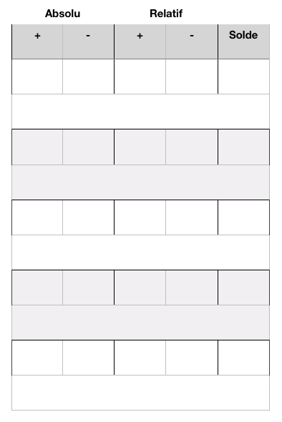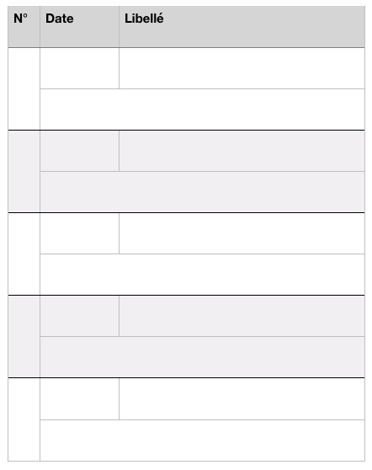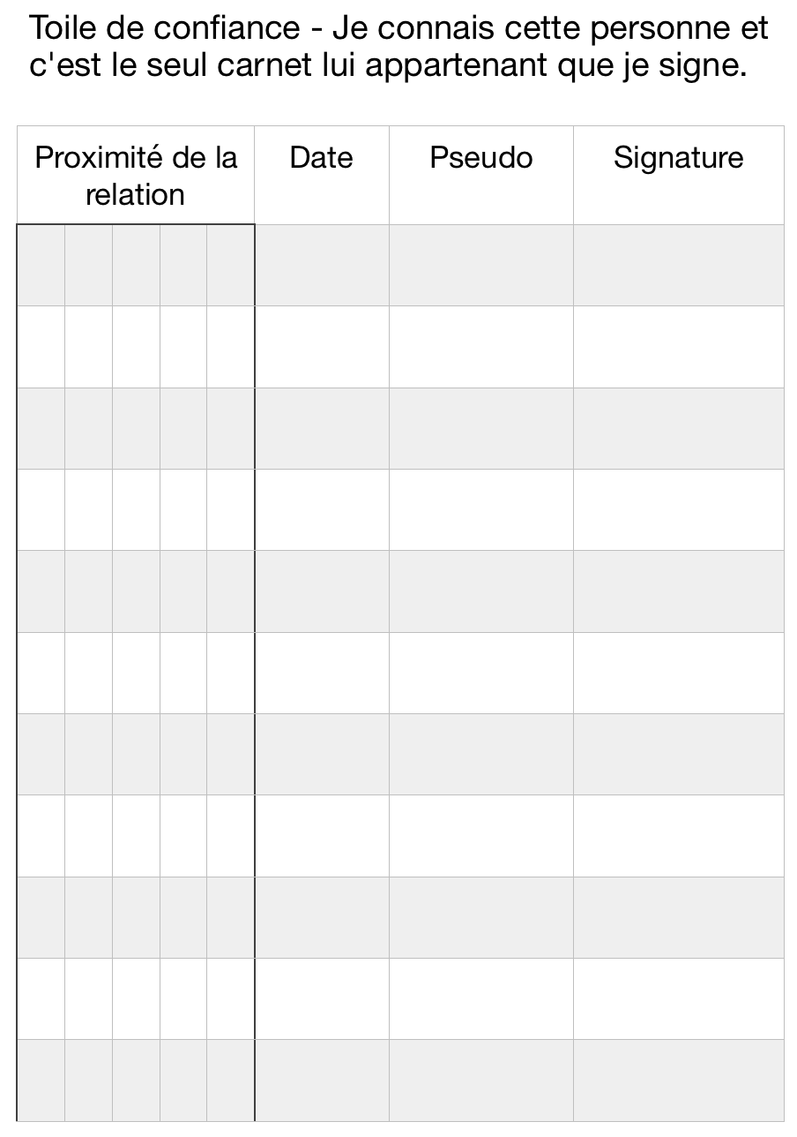

| Absolu | | Relatif | |  |
| --- | --- | --- | --- | --- |
| + | - | + | - | Solde |
|  |  |  |  |  |
|  | | | | |
|  |  |  |  |  |
|  | | | | |
|  |  |  |  |  |
|  | | | | |
|  |  |  |  |  |
|  | | | | |
|  |  |  |  |  |
|  | | | | |



|  |  |  |
| --- | --- | --- |
| N° | Date | Libellé |
|  |  |  |
|  | |
|  |  |  |
|  | |
|  |  |  |
|  | |
|  |  |  |
|  | |
|  |  |  |
|  | |

| Absolu | | Relatif | |  |
| --- | --- | --- | --- | --- |
| + | - | + | - | Solde |
|  |  |  |  |  |
|  | | | | |
|  |  |  |  |  |
|  | | | | |
|  |  |  |  |  |
|  | | | | |
|  |  |  |  |  |
|  | | | | |
|  |  |  |  |  |
|  | | | | |